**UNSEND BUTTON**

[](https://1.bp.blogspot.com/-wzEavRkZipQ/W8Ie-CizEeI/AAAAAAAAAO8/phk35zpe5RE16X3HSw0mZjcrKCWL6FL6ACLcBGAs/s1600/1_QeOrf-n5NAdxp0AxHIGlsw.jpeg)

There were some issues in earlier **April** about [Mark Zuckerberg](https://en.wikipedia.org/wiki/Mark_Zuckerberg)'s Facebook messages. [TechCrunch](https://techcrunch.com/) broke that **Mark Zuckerberg** deleted some of his messages from **recipients inbox**. That was so much unusual. Which was a violation of Facebook's other **policy**. But on the very next morning, [Facebook](https://www.facebook.com/) announced that they will build this button for everyone. But since then there weren't any clues about it. Last week, TechCrunch asked Facebook about it and they said it is not official yet but they are trying their best for this feature.

[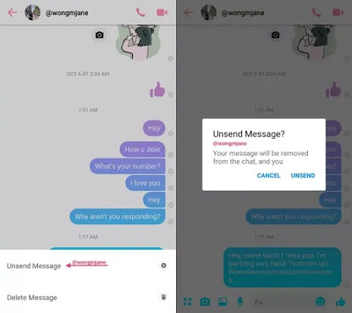](https://1.bp.blogspot.com/-7DZ3oANvFLw/W8IfMaSwx1I/AAAAAAAAAPM/1atMGQvY6zIBnpRCe4D-qfQBdezQIe3CACEwYBhgL/s1600/Facebook_Unsend_Button.jpg)

Facebook doesn't have any unsend button but [Snapchat](https://www.snapchat.com/l/en-gb/) had released their unsend button in June. And many other social media like Whatsapp has their unsend button. Also, Gmail has an unsend option which helps users to delete the email after sending it. Gmail gives **30sec** for deleting the mail without **recipients** seeing the mail. That's why Facebook is also thinking about this.

[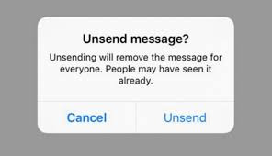](https://3.bp.blogspot.com/-Gv1z8eR5MhE/W8IgX0XV5JI/AAAAAAAAAPY/Y06tpwHOXJMPa8WjiF2Hh8MB_zknOSvzACLcBGAs/s1600/images%2B%25281%2529.jpg)

The **unsend button** will help many users in various ways. Like someone said something stupid or embarrassing to anyone. Sender finds this thing awkward after sending the message then he can use the unsend button. It will help him to delete the message. For deleting message there will be a confirmation pop up, if he surely wants to delete his sent message also from recipients inbox.

[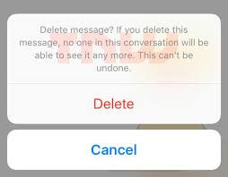](https://1.bp.blogspot.com/-WfCWhLoJLVU/W8Ifb7JrtyI/AAAAAAAAAPI/G1JOgLTBId8MKExyioyRguG01tyDpJ1LQCEwYBhgL/s1600/images.jpg)

There can also miss use of this button. If a **cybercrime** is committed in messenger through the message. He or she can delete the message or proof from recipients inbox.

A spokesman confirmed that Facebook tested this product before launching. It is not still official from Facebook. But they are determined about this feature. Which will help users a lot.